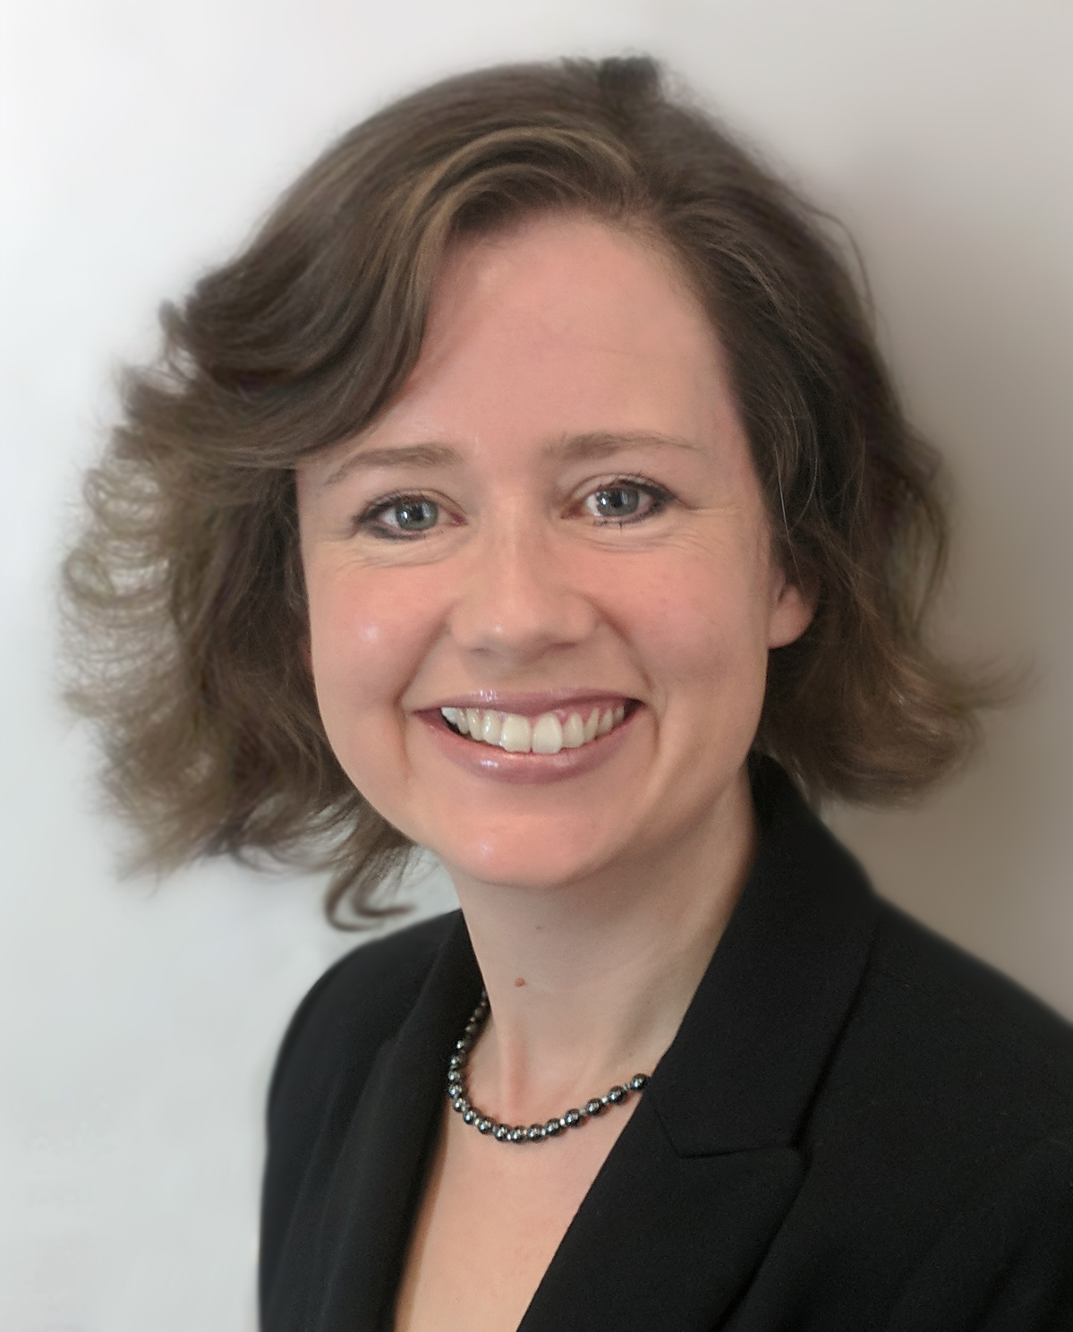
Arabella Tresilian MAHons PGDipEd

Independent mediator and trainer, specialising in health, social care and wellness, for businesses, service providers and communities
- Mediator, fully-accredited by the Centre for Effective Dispute Resolution (CEDR)
- Dispute resolution in employment, workplace, civil, commercial & community cases
- Experienced company director, charity trustee/chair, organisational consultant, commercial partnerships consultant, trainer, educator, healthcare service user and family carer
- Knowledge of health conditions including: mental health, learning disabilities, autism spectrum conditions, deafness, stroke, dementia, neurocognitive conditions, life-limiting conditions and end-of-life
- Experienced trainer with Postgraduate Diploma in Education (Leadership & Management)

Arabella is an independent dispute resolution consultant and trainer, specialising in dialogue facilitation, conflict resolution and partnership-building, wherever health and wellness are central factors. Using her lived experience as a patient and carer, combined with twenty years experience as a management/ OD/HR consultant and trainer, she supports organisations, service providers, boards, teams, employees, families, care homes, hospitals and individuals in finding effective resolutions to complex disputes and relationship-breakdowns. Her training workshops give organisations the skills and confidence to proactively prevent and resolve difficulties themselves.

Services for businesses, service providers and communities:

Resolution:
- Full mediation service
- Dialogue facilitation
- Conflict coaching
- Team dynamic development
- Change strategy
- Meeting facilitation

Training & Speaking – bespoke formats including:
- Conflict prevention and management
- Difficult conversations
- Team communications
- Mental health awareness
- Dialogue skills for frontline staff
- Mindfulness for wellbeing

Arabella’s current affiliations include:

- Centre for Effective Dispute Resolution – Associate to CEDR Skills
- Bristol Mediation – Community Mediator and Mentor Mediator
- Association of South West Mediators – member
- Civil Mediation Council – registered via Association of South West Mediators
- Mind (Bath) – Associate Trainer
- Equisphere Employability – Co-Founder & Trainer
- National Institute of Health Research – Public & Patient Involvement Reviewer
- The Health Foundation / NHS Improvement – Fellow of the Q Community
- Mental Health First Aider

Rates
Contact me to ask me about my rates, and about my discounts for families, charities, not-for-profits and public sector services – arabella@arabellatresilian.com or 07769 774671

Mediation Testimonials (2018)

“If Arabella could clone herself and send us a copy! Clear structure for the day. Safe space and generosity to us all.” (HN, board dispute)
“Fantastic facilitation. Handled really well. A very productive, well-structured approach to problem solving.” (VW, trustee, charity board dispute)
“Arabella brings integrity to her every interaction. She communicates with centred grace, allowing each person to feel heard – their perspective acknowledged, their feelings validated. Her genuine and open manner reassures; her astute observations of an individual's unique qualities inspire.” (RB, LLB)
“I keep saying thank you. But I’m so glad I met you and you were prepared to think all this through with me. You’ve made such a difference to my life and those around me.” (SD, family case)
“Arabella was supportive and constructive in our preparations for, and experience, of mediation. Her emphasis on expressing our feelings led to a more positive outcome than we had anticipated.” (WT, committee members’ dispute)
“Please consider yourself delighted in and appreciated; thank you for being so generous with your time... Your warmth, humanity and empathy are something for which I am profoundly grateful.” (JC, trustee, charity board dispute)
“Kept things open and calm. Structured well. Many thanks for a safe ‘space’ and thanks for helping us move forward.” (BM, trustee, charity board dispute)

Training Testimonials (2018)

“Best training session I’ve ever been to! Three hours of workplace mental health training? I was dreading it. But it was the best session I’ve ever been to - and I've worked here since 1985!”
“Excellent trainer. I was engaged for the full amount of time.”
“So far the best training we’ve had in our company.”
"Seamless training."
"10/10!"
“I thoroughly recommend this to anyone!”
“I particularly enjoyed bringing a team of senior leaders together to hear and discuss the same messages.”

In 2018 Arabella worked and collaborated with organisations including:

- Adult Care Mediation
- Bath Mind
- Bath Digital Festival
- Bath Spa University
- Bath & North East Somerset Public Health
- Bristol Mediation
- BuroHappold
- Centre for Effective Dispute Resolution (CEDR)
- Curo
- Enable Law
- End of Life Doula UK
- Mayden Academy
- Network for Creative Enterprise
- Oxford Brookes University
- Oxford Mediation
- The King’s Fund
- Royds Withy King LLP
- Royal United Hospital NHS FT
- University of Bath
- Visit Bath
- WEASHN (West of England Academic Health Science Network)

In 2018 Arabella was featured as a speaker / contributor for:

- BBC Radio 4 Inside Health – interviewed on social prescribing
- British Medical Journal – contributor to article on social prescribing
- Financial Times – contributor to article on social prescribing
- BBC News (News at Six / Ten) – contributor on Universal Credit
- The King’s Fund ‘Social Prescribing – Coming of Age’: speaker, sharing billing with Secretary of State for Health
- Elder Mediation World Summit & Symposium 2018 – paper on ‘End of Life Conversations’

