Engagement Form

Thank you for getting in touch with me to provide mediation, conflict coaching or dialogue facilitation services to you, your organisation, your colleagues or your clients. This form allows me to know a) who is my Lead Contact and b) who is involved in the situation needing my support. Traditionally, we call the situation needing support a ‘case’ and the person/people involved in the case, the ‘party’ or ‘parties’.

The information given on this form is held confidentially by me and no one will be contacted by me without consent from the Lead Contact. It’s fine if you are not sure how to fill in any parts of this form – we can always talk it through later.

I look forward to working with you to find a resolution to the situation at hand. Please remember you can contact me with questions or concerns at any stage of the process.

Best wishes,
Arabella

Lead Contact
Your name
Your organisation (if applicable)
Your address
Your email address
Your phone number
Are you also a party in the case? |  | Yes / No
The people (parties) involved in the case
Name  (or initials) | Role / job title |  | Phone number | Email address |  | May I contact them?
How can I help? Please give me a brief overview of the case and what you hope to achieve through working with me. Tips – How did the issues begin? What’s the situation now? What would a good future outcome look like?
By what date would you hope to have a resolution to the case? |  |  |  |  | dd / mm / yy
Are you happy with my Terms?: http://arabellatresilian.com/terms/ |  |  |  |  | Y / N
Any Questions or Concerns?

Please email this back to me at: arabella@arabellatresilian.com and I will get back to you as soon as possible.

Resources for you:

- Preparing For Your Mediation - this is a useful article: https://mediate.com/articles/sebokt.cfm

- Knowing what to expect in mediation:

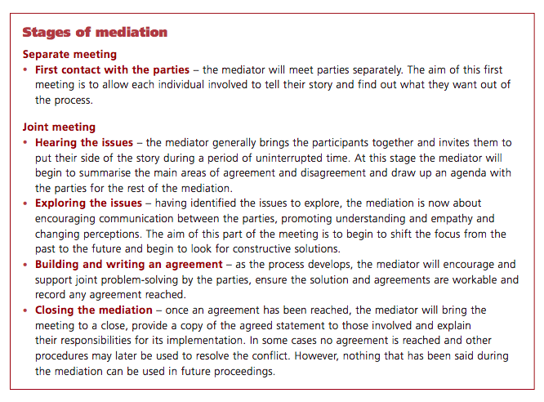

Source: http://m.acas.org.uk/media/pdf/n/n/Mediation-an-approach-to-resolving-workplace-issues.pdf

NB: This document is confidential to Arabella Tresilian and the Lead Contact

